Dr. Adam Wells
Wiley 004
276-944-6150
awells@ehc.edu
Office Hours: M, W, F 10-12,
and by appointment.

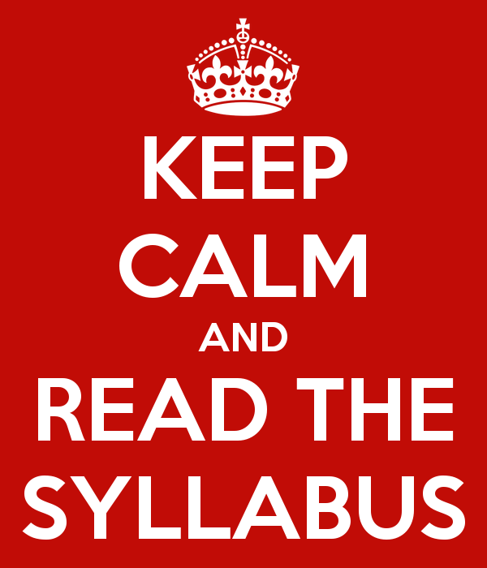

Religion 314: Islam

This is a historical and topical survey of the origins and development of Islam. The course is primarily concerned with the life and career of Muhammad, the teachings of the Qur'an, the development of the Muslim community, its principal institutions and schools of thought. Our guiding questions are: How did Islam originate? What are Islam’s core tenets? How has Islam developed and changed throughout history? How have Muslims dealt with the challenges of modernity and Western imperialism? What can Islam teach us about our own traditions?

COURSE GOALS:
Upon successful completion of this course,
- The student will be familiar with the historical development of Islam.
- The student will have an appreciation for the diversity of religious practices and beliefs within Islam.
- The student will be able to employ critical thinking skills in evaluating various Islamic philosophical texts.
- The student will be able to relate the religious traditions he/she studies to his/her own tradition (whether that tradition be religious, secular, or otherwise).

TEXTS (required, available at the Bookstore):
1) Marshall G. Hodgson. The Venture of Islam, Vol. 1 (Chicago: University of Chicago Press, 1974).
2) Seyyid Qutb. Milestones (CreateSpace, 2005).
3) Fazlur Rahman. Major Themes of the Qur’an, 2nd ed. (Chicago: University of Chicago Press, 2009).
4) Abdulaziz Sachedina, The Islamic Roots of Democratic Pluralism (Oxford: Oxford University Press, 2007).

SCHEDULE OF LECTURE TOPICS AND READING ASSIGNMENTS *

INTRODUCTION

Week 1 (1/13-15): Introduction to the Study of Islam

a) Edward Said, Orientalism, pp. 31-49 (Moodle)
b) Xavier Clooney, Comparative Theology, Ch. 1 (Moodle)
c) William Shepard, Introducing Islam, pp. 1-10 (Moodle)

UNIT I: THE PROPHET AND QUR’AN

Week 2 (1/20-22): Pre-Islamic Arabia and the Emergence of the Prophet
Readings:
- Hodgson, pp. 103-167
- Lings, Muhammad, pp. 1-26. (Moodle)

Week 3(1/27-29): Biography of the Prophet
Readings:
- Hodgson, pp. 167-196
- Shepard, Introducing Islam, pp. 71-83 (Moodle)

Week 4 (2/3-5): the Qur’an
Readings:
- Rahman, pp. 1-79
- Qur’an, suras 1-3

Week 5 (2/10-12): the Qur’an continued
Readings:
- Rahman, pp. 80-149
- Qur’an, suras 4-7

UNIT 2: THE MUSLIM STATE

Week 6 (2/17-19): the Early Muslim State and High Caliphate
Readings:
- Hodgson, pp. 197-279

Week 7: (2/24-26): The Caliphate and Shari’ah
Readings:
- Hodgson, pp. 280-358

Week 8 (3/3-5): Personal Piety, Philosophy, and Theology
Readings:
- Hodgson, pp. 359-443
- Selections from Avicenna and Al-Ghazzali (Moodle)

UNIT 3: ISLAM AND MODERNITY

Week 9 (3/17-19): Transition to Modernity

a) John Esposito, Islam: the Straight Path, pp. 55-83, 141-186

Week 10 (3/24-26): Islam and the West: A Clash of Civilizations?
Readings:
- Bernard Lewis, “The Roots of Muslim Rage” (Moodle)
- Qutb, Milestones

Week 11 (3/31-4/2): Islam and Democracy
Readings:
a) Sachedina, The Islamic Roots of Democratic Pluralism

Week 12 (4/7-9): Student Choice
Week 13 (4/14-16): Student Choice
Week 14 (4/21-23): Student Choice

_________________________________________________________________________________________________

Course Requirements

- Participation: Your informed participation is required! Be present in both mind and body! Do the readings! Ask questions!

- Pop presentations (5%) At least once during the semester you will be called upon at random to present on the reading. When I call on you for your presentation, you will be expected to generate discussion: raise some questions, state your own opinion, explain why you think the reading is relevant (or not, as the case may be), bring in what you know from other classes, etc. You are not required to do each of these things, and you—like I—should expect that your peers have done the reading and do not need to have the arguments explained to them. Instead, you are simply required to prod the discussion along. This is your chance to hone your analytical reading skills (close reading requires taking notes, reflecting, etc.) and to steer the conversation in a direction you find interesting. Each student will have two opportunities to present to the class. Although you will not be required to lead discussion for the entire class period, I reserve the right to decide when to jump back in.

The grade for these “pop presentations” will be A, C, or F: If you’ve clearly done the reading and put thought into your presentation, you will receive an A. If you’ve done the reading but your presentation is somehow lacking, you will receive a C. If you clearly haven’t done the reading, you will receive an F.

- Group work and class presentation (10%) The topics and readings for the last three weeks of class are up to you! I will divide you into groups. In consultation with me, your group will pick a topic and 35-50 pages of reading. On your assigned day, your group will be responsible for leading class. This is your chance to investigate something that interests you about Islam! Here are some possible topics:
  - Islam and women (veiling practices, feminism).
  - Historical origins of the ISIS movement.
  - Islam in the American Civil Rights Movement.
  - Islam in prisons.
  - Islam and religious violence.
  - Islam and the legacy of colonialism.
  - Islam after 9/11
  - Islam and theocracy.
  - Reactions to representations of the prophet (Danish cartoons, attack on Charlie Hebdo).
  - Radicalization of western muslims.
  - Islam in modern Europe and North Africa (e.g., head scarf controversy in France, secularism in Turkey, Arab Spring)

- Midterm (25%) Your take-home midterm will be due on March 6th by midnight. It will be open note/ open book. You may not use any internet sources.

- Final (30%) Your take-home final will be due on May 1st by midnight. It will be open note/ open book. You may not use any internet sources.

- Research Paper, 3500-4000 words (30%). You will write a well-researched paper on a topic of your choice. You should meet with me individually before Spring Break to discuss your topic and potential sources. Your paper will be graded on the quality of your writing and research. Sources gleaned from Google (and other non-academic internet search engines, encyclopedias, blogs, etc.) are unacceptable. Good research requires work! Pick a topic early, and consult me (and our wonderful librarians) about finding legitimate sources. The word limit is strict. Unless you have explicit permission from me, you may not write a shorter or longer paper.

GRADING RUBRIC

Letter Grade | Lower Numerical Cutoff | Description
A | 94 | Exceptional work that shows creativity and careful analysis of material. A-level work is sophisticated, well-written, and free from errors in grammar and spelling.
A- | 90 | Shows exceptional mastery of concepts, and goes well beyond requirements.
B+ | 87 | Work in the B-range is above average. B level work may be excellent work with several small errors or flaws. It is solid work, and shows significant command of concepts.
B | 84
B- | 80
C+ | 77 | Work in the C-range is average and satisfactory. It fulfills the criteria of the assignment, but does not display the same level of analysis, comprehension, and/or creativity as B and A-level work
C | 74
C- | 70
D | 60 | Work in the D-range is substandard. It may have major flaws, or show little mastery of major or minor concepts.
F | 0 | Work in the F-range shows no mastery of relevant material. F-level work fails to complete requirements or is otherwise unacceptable.

**Letter grades will be equivalent to a numerical score 1 point above the lower numerical cutoff. For example, an A paper is equivalent to a numerical score of 95.
_________________________________________________________________________________________________

ATTENDANCE POLICY:
During your college years, by responsible class attendance you can establish a reputation for reliability that will help your professors to write good reference letters for jobs or programs of graduate study. I value faithful attendance highly, as an indication of your commitment to the course goals.

You are allowed two excused absences. You may request that an absence be excused for an appropriate reason such as sickness, a medical appointment, athletic competition, dangerous driving conditions, etc. An excused absence is based on an email request from you (not on a note from a nurse, a list from a coach, or your telling me why you missed class). Before or right after any absence, please email me, giving the date and the reason that you missed class, if you want me to consider excusing the absence. Unexcused absences will reduce your course average by 2 points for each such absence.

Note: If you do not email me before or soon after your absence, I will assume that it is unexcused.

PARTICIPATION POLICY:
Informed participation is expected. You should be physically and mentally present and engaged in every class! Your learning process will be helped immensely by actively participating in the course, so don’t be afraid to ask questions, or engage your peers (and me) in discussion. Follow the Apostle Paul’s advice: Be bold!

Non-participation (e.g., sleeping, staring off in the distance for extended periods of time, disruptive behavior, and so forth) will negatively impact your course grade.

COMPUTER AND CELL PHONE POLICY:
A successful class requires the active participation of everyone involved. Cell phones are distracting and disruptive; they are detrimental to both individual learners and the class as a whole. Consequently, the use of cell phones in class is strictly forbidden. Turn them off before class begins—off, not vibrate! I will give you one warning per semester, after which I will deduct one point from your final grade for every violation of this policy. If I see your cell phone during an exam or quiz, you will automatically receive a ZERO on that exam or quiz.

The use of laptops in class is prohibited unless you receive an accommodation from the Powell Resource Center.

POLICY ON ACADEMIC DISHONESTY:
The Emory & Henry College Honor Pledge is as follows:
I understand that Emory & Henry is a community built on trust. Therefore, as a member of this community, I am committed to tell the truth and to maintain the sanctity of other people’s property, including computer data/access. I will abstain from all fraud in academic work. I will neither give nor receive aid on any form of test or assigned work where such aid is prohibited, nor tolerate this conduct in any member of the Emory & Henry Community. I will deal responsibly with such acts when I observe them. By my conduct and influence, I will endeavor to build a high standard of honesty and truthfulness in all academic work.

Any evidence of academic dishonesty may result in a grade of F for the assignment or failure of the course. Academic dishonesty includes such acts as receiving improper assistance on tests and quizzes. For writing assignments, academic dishonesty includes plagiarism, which is work copied or paraphrased from another source without proper citation, copied from your own work for other classes, or written or revised by someone else. If you refer to another source, you need to give credit directly to that source when you quote directly and when you paraphrase. Any incidents of academic dishonesty will be reported and dealt with in adherence to the College’s Honor System procedures.

EMAIL POLICY:
I would much rather meet with you in person than correspond via email. However, I will make every effort to be available to by email during the workday. If you send an email after 4:00pm, you should not expect a response until the next working day. If you do not receive a response from me within two working days (note: that does not include weekends), feel free to send me a reminder. I often get 30-50 emails per day. It is very easy to overlook one. Keep in mind that I do not have time to answer complex questions by email. If your query requires an answer of more than a few sentences, you should come by my office.

How to Get the Most Out of This Course

As with any course, what you invest will determine your return, not simply in the grade you earn but in the knowledge and perspectives you take with you. Things to do, more or less in order of importance, are:

1. Keep up with the assignments. There is a good deal of reading in this course. Stay current with the reading assignments. If you fall behind you will have a hard time catching up.

2. Prepare conscientiously for class discussions. Read closely the texts assigned, ponder the questions provided, make notes, and be ready to participate in discussion in a thoughtful and well-informed manner.

3. Take advantage of the office hours of the instructor. My office hours are for your benefit. They provide opportunities for you not only to ask questions and obtain clarifications, but also to get to know me and to let me get to know you.

4. Familiarize yourself with the specialized vocabulary of the academic study of religion. There are many technical terms and fifty-cent words: learn what they mean and how to pronounce and spell them. To this end, you should freely and frequently consult reference materials.

5. Familiarize your self with Arabic names and terms. You will encounter quite a few foreign names and terms in this class. Make an effort to learn them! Many students find flashcards helpful.

5. Make use of resources beyond those required for reading or purchase. There are many, many commentaries, dictionaries, concordances, etc. Don’t be afraid to consult outside sources!

